Ruprecht-Karls Universität Heidelberg

Geographisches Institut

Berliner Straße 48

69120 Heidelberg

**Impact of a new minimum distance between wind turbines and settlements –**

GIS Analysis with free geodata

Course: **GIS Analyses with Free and Open-Source Software**  
Winterterm 2019/20

|  |  |
| --- | --- |
| Lecturer: | Christina Ludwig, M.Sc |
| Handed in by: | Group 5:   |  |  | | --- | --- | | Carsten Gawlas  Student Id: 3604077  bs251@stud.uni-heidelberg.de | Ulrike Lorenz  Student Id: 3600484  Ulrike.Lorenz@stud.uni-heidelberg.de | |
|  |  |
| Heidelberg, | 10 April 2020 |

**TABLE OF CONTENTS**

TABLE OF FIGURES II

TABLE OF CHARTS II

ABSTRACT III

1 Introduction 1

1.1 Target/Hypothesis: 1

1.2 Location 2

2 Background 3

3 Data/Methods 5

3.1 Data 5

3.2 Methods 7

4 Results 10

5 Discussion 13

6 Outlook 14

7 Declaration of Authorship 15

8 Sources: 16

# TABLE OF FIGURES

Figure 1: Map of the research area 2

Figure 2: Elevation of the Research Area 3

Figure 3: Nameplate capacity of wind energy per year 4

Figure 4: Net electricity production in Germany (2019) 4

Figure 5: Workflow 9

Figure 6: Result of the two distances 10

Figure 7: Centroids of the most suitable areas with the old and new buffer distance to settlements 12

# TABLE OF CHARTS

Table 1: Data Sources 6

Table 2: Comparison of the not available area regulated by minimum distances to infrastructure and settlements 10

Table 3: Classification of land uses for a wind turbine park 11

# ABSTRACT

Germany wants to shift its energy sources from fossil to renewable sources. The biggest share from renewable source is planned to be wind energy. To fulfil this task, the German government increased the capacity for wind turbines. That lead to the fact, that nearly 25% of the electricity in Germany was produced from wind energy in 2019. Although the expansion of wind turbines slowed down rapidly, there were different proposals to increase the build-up of wind turbines again. This paper examines the idea of increasing the minimum distance between wind turbines and human settlements. Therefore, the areas, in which potential wind turbines could be build, were researched. First the area with the old requirements and then with the new proposal were calculated and then compared. The calculation was done with the graphical modeler for QGIS. The data used in this paper was open source, as were the used tools. The documentation is uploaded on GitHub (https://github.com/UlrikeLorenz/Final_Project_Group5) and available for repetition of the calculation or for applying this method on other areas. In this paper the API overpass turbo was used to download the Data from OSM. The code can easily be modified to any other region in Baden-Württemberg (Germany). This paper shows that for the region of Rhein-Neckar-Kreis and Neckar-Odenwald-Kreis the change of the minimum distance makes a significant difference. Some areas that were appropriate were no longer available according to the new minimum distance to settlements. Especially for Rhein-Neckar-Kreis the impacts were significant: Only few areas were available by the old minimum distance to settlements and with the new regulations it would be even less and makes the implementation of the goals impossible within the area itself. This seems to be less problematic in Neckar-Odenwald-Kreis but will probably be a problem in other regions in Germany too.

# Introduction

Germany works on the shift from fossil energies to renewable energies. This is even enshrined in German laws. The main part of the energy from renewable energies is wind energy. The state of Baden-Württemberg in southern Germany aims to get 10% of the energy needed out of wind energies produced within the state until 2020 (Windenergieerlass Baden-Württemberg 2012). Because of a raising resistance of local residents against wind turbines, there were different ideas and approaches to get a higher acceptance within the population. In 2019 the German Government suggested a new law for wind turbines. The proposal commands a new minimum distance of wind turbines from settlements. Even though the proposal is not yet implemented, it raised many questions on the impact of this law. The idea has caused strong sceptics, if the actions fulfils the task. The board member responsible for the energy policy of the union Verdi, Wolfgang Lemb disagreed with this idea. He said that the new minimum distance of 1000m will not increase the acceptance, it will only decrease the potential area for wind turbines (Der Spiegel 2020). The questions are, how much area will be affected by these new requirements? Will the new minimum distance have an impact in impeding the goals for expanding wind turbines?

## Target/Hypothesis:

To achieve the goal of more renewable energies it is necessary to find suitable places for new wind turbine parks. The target of this project is to calculate the total area, which is lost as potential locations for wind turbine parks by the new required distance to settlements. Is the new distance creating a big (significant) impact?

Furthermore, the available areas will be evaluated and clipped by further relevant data like maximum slope, wind data and land use. This will answer the Question: Which area/s is/are most suitable for a wind turbine park in the studied area? This will also show if the new distance has a significant impact on the size and geographical position of the most suitable area(s).

## Location

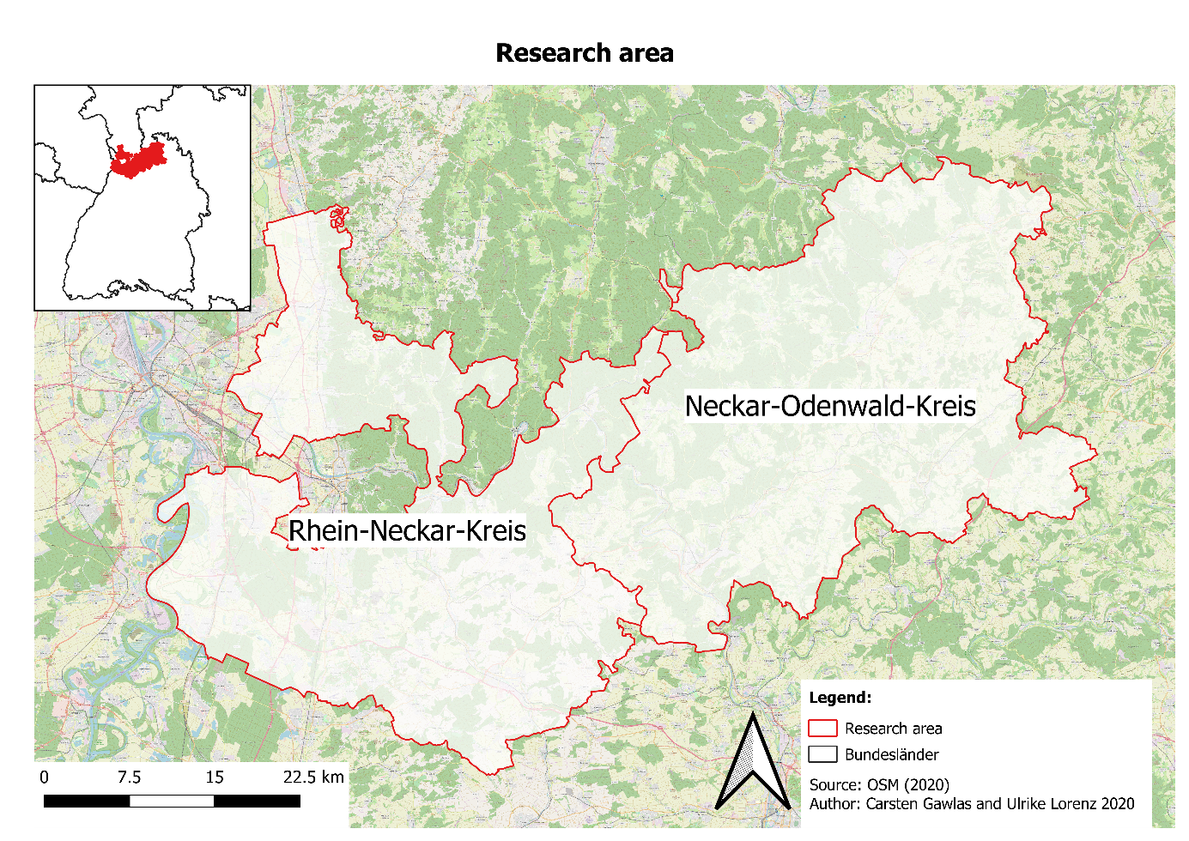The research area consists of the Rhein-Neckar-Kreis and the Neckar-Odenwald-Kreis. The research area is near the City of Heidelberg (see Figure 2: Map of the research area), which is located in the south-west of Germany, in the north of Baden-Württemberg. It is assumed that both the region of Mannheim and the region of Heidelberg are not suitable for a wind turbine park, because the regions are to small and the population density is too high. Because of that, the analysis for possible locations for wind turbines is performed within the regions of Rhein-Neckar-Kreis and Neckar-Odenwald-Kreis (see research area in Figure 1). The research expands over two main districts, this is the Oberrheingraben in the west, which has a very low Elevation (see Figure 2) and nearly no slope. In contrast to the other region, the Odenwald. The Odenwald is in the north and north-west of the Region. This mountain region has a higher elevation and has a heterogenic surface, with peaks and valleys, so the slope is much higher. That means the research area consist of two different regions, one fairly flat and dominated by agriculture and the other one hilly (Figure 2: Elevation of the Research Area).

Figure 1: Map of the research area

Source: own map with data from OpenStreetMap contributors (2020)

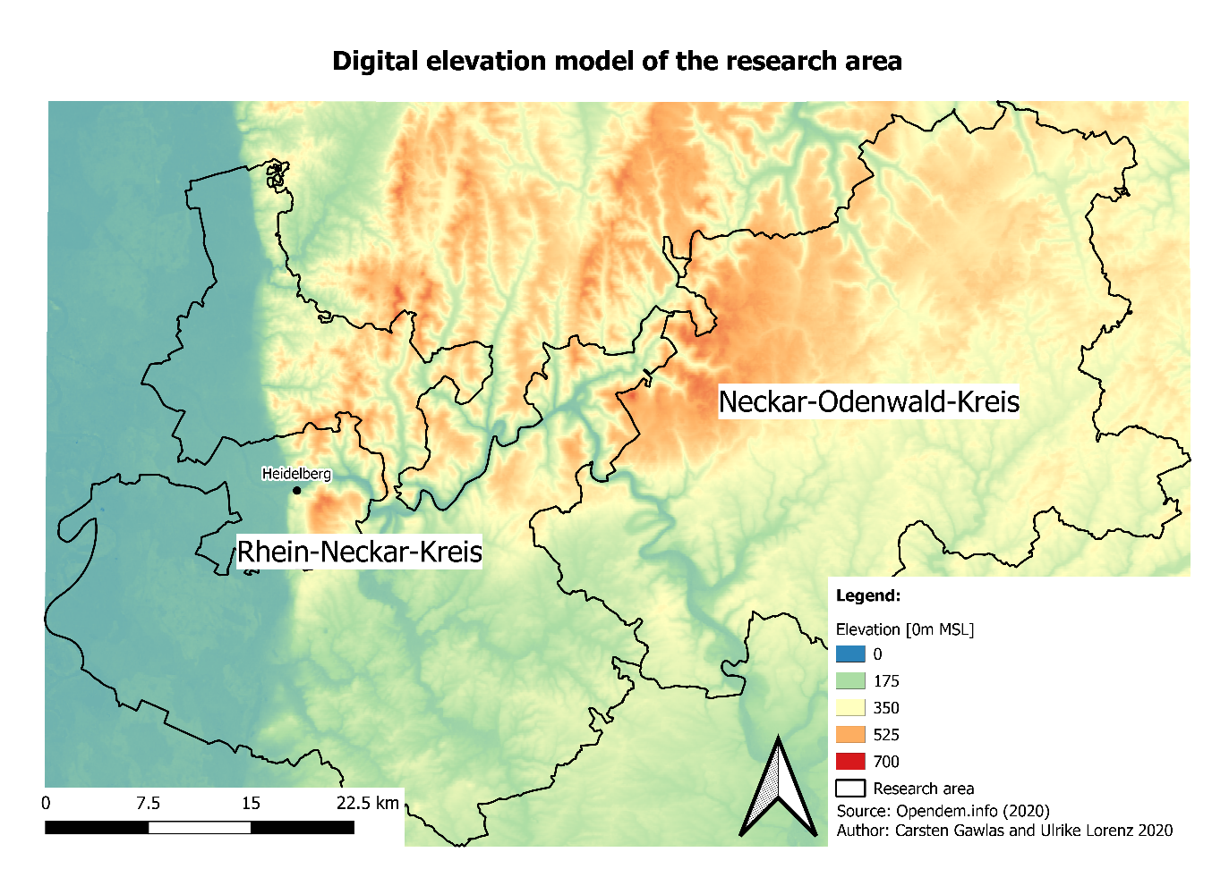Figure 2: Elevation of the Research Area

Source: own map with DEM from Opendata.info (2020)

# Background

In 2019 127,22 TWh of electricity was produced by wind turbines in Germany. This is 24,6% of the total generated electricity in Germany in 2019. This means that wind energy is the biggest energy source in Germany (see Figure 3). The production growth from 2018 to 2019 was nearly 16%. The total wind energy production is divided in offshore and onshore wind energy. The onshore wind turbines produced in 2019 102,6 TWh, so they are much more important currently than the offshore turbines, which produced 24,62TWh (Burger 2020: 5).

A big Problem is the fluctuation in the amount of energy gained from wind. In Germany the gained energy from wind, changes on a daily and monthly basis. For example, in 2019 the amount of energy changed from 18 TW/h in March to 6 TW/h in August (Burger 2020: 28). The main problem is that the build-up of wind energy is decreasing (see Figure 3). Specially the expansion of onshore wind turbines is slowing down since 2017 (see Figure 3). That the capacity for wind energy is not increased, poses an urgent problem, because the goal to shift completely from fossil energy to renewable will then not be possible. The new law for stopping the use of coal till 2038, the Kohleausstiegsgesetz (Bundesregierung 2020: 17) will also increase the pressure on the expansion of wind energy capacity.

Figure 3: Nameplate capacity of wind energy per year

Source: own Figure with data from Burger 2020: 58

Figure 4: Net electricity production in Germany (2019)

Source: Own Figure with data from Burger 2020: 13

To find suitable areas there many different criteria must be considered, the most important criteria being to find a suitable location for a wind turbine park are the wind speed and the profitability considering the energy the park can produce and the cost of building and operation services. Criteria are divided in two groups: knock-out criteria and trade-off criteria. Knock-out criteria consider any form of settlement, traffic areas, energy pipelines/cables, radio stations, military stations, airports (no matter which size), nature and landscape aspects, waterbodies, some sorts of forest (protected, to use for relaxation or soil protection) and areas where natural resources are exploited. Trade-off criteria consider also nature and landscape aspects, regional important relaxation areas and cultural and soil landmarks (Gesellschaft für Landmanagement und Umwelt mbh 2013). For many of these criteria a certain distance to wind turbine parks is necessary as proposed in Bergmann and Höfle (2013).

# Data/Methods

The potential of free geodata in comparison with official geodata was investigated by Bergmann & Höfle (2013). They concluded that the free geodata are not as exact as official data, yet the spatial location is nearly identical. In their conclusion free geodata can be used, to detect areas with potential locations for wind turbines.

To determine potential location, different parameters must be considered. This is the optical impact of wind turbines, which was analysed in a GIS-based approach by Taeger & Ulferts (2017). A different parameter is noise, but beyond a distance of 1000m noise surveys are no longer necessary (Lechleitner & Bohm 2016).

## Data

In this project free geodata, like from OpenStreetMap will be used. The reasons for using free Geodata is, that it is free, repeatable, easier to access and has already been used in analysis of potential wind turbines location (Bergmann & Höfle 2013). Within that study several tags are used to get the useful data, which will be adapted to our study and used in this analysis too. The following tags should be used for the analysis: landuse=residential/ farmyards/ industrial/ commercial, railway, aeroway=runway/ taxiway/ terminal, power=line/ minor_line, highway=motorway/ motorway_link/ trunk/ trunk_link/ primary/ primary_link/ secondary/ tertiary (Bergmann & Höfle 2013, adapted).

For the regions either OSM data (boundary=administrative (admin_level=8)) or other data sources (e.g. https://gadm.org/download_country_v3.html) can be used.

To get the best results both datasets should be downloaded and compared to find out which one suits best for the analysis and to get an impression of the OSM data.

For the analysis is an elevation model necessary, free data for this is provided by several sources. The main difference is the spatial resolution. The considered research area in this project, is a small area (2186.17km²). This means a high spatial resolution is necessary. This can be found at https://www.opendem.info/download_srtm.html (Opendata.info 2020).

Winddata can be found from several sources too. The most reliable sources for this project are the “Windatlas Baden-Württemberg” (https://www.energieatlas-bw.de/wind/windatlas) and the German weather service. The data given by the German weather service, includes predictions for the future ( https://www.dwd.de/DE/leistungen/quwind100/qu-wind_100.html).

Table 1: Data Sources

|  |  |  |  |  |
| --- | --- | --- | --- | --- |
| Name | Content | Spatial resolution | Year from | Source |
| Windatlas Baden-Württemberg | Winddata in an elevation of 100-200 m above the ground (used here: mean wind speed in 200 m) | 30 x 30 m | 2019 | https://www.energieatlas-bw.de/wind/windatlas |
| DEM | Elevation | 0.0008333333333333301342 x 0.0008333333333333301342 ° | 2020 | https://www.opendem .info/download_srtm.html |
| CORINE Landcover von Copernicus | Landusedata | 100 x 100 m | 2017-2018 | https://land.copernicus.eu/pan-european/corine-land-cover/clc2018 |
| OSM | Aeroways, farmyards, industrial/commercial areas, streets, regions, powerlines, wind turbines | - | 2019-2020 | https://www.openstreetmap.de/karte.html |

## Methods

The analysis will mostly be done with QGIS. Depending on the datasets the preprocessing can be done with the help of GDAL. The data can either be downloaded by hand or by an automated script containing the OSM tags.

Every dataset must be buffered with the distance that is required according to German law. To see the difference that results from the new proposed distance to settlements, that layer must be buffered twice: With a buffer distance of 1000 m and a buffer distance of 700 m. All buffer layers must be merged and clipped with the administrative areas of the two regions to see possible areas for wind turbine parks and if the areas change depending on the new distance to settlements. For the possible areas an elevation analysis is needed to see if the areas are flat enough to build a wind turbine park on them.

Dolinski et al. (2012: 25-37) propose an analysis with commercial programmes, but most of the analysis can also be done with QGIS. For analysing the parameters for the potential wind turbine location, a script for GRASS GIS can be used (Bergmann & Höfle 2013: 485). Using free software and data allows the repetition of this analysis in different areas.

The input data must be weighted according to their importance. The most important data to find the most suitable area for a wind turbine park is of course the wind itself. On one hand if there is no wind or too little in the height of the wind turbine (about 150-200 m above the ground) wind turbine park would make no sense. On the other hand, even if there is wind it should not be too windy. Otherwise the wind turbine park has to be shut down, in situations where the wind speed is too high. This would mean, that the energygain would be lowered. On top of that, the elevation and slope should be considered. Both are important factors because if an available area is in a valley, it is not reasonable to build a wind turbine park there. Another knock out criteria is the slope, as wind turbines can only build on small slope. High slope values would mean that the area contains a hillside which means that the wind park would contain wind turbines on lower sites which would produce less energy. For this reason, the elevation should preferably be more or less evenly distributed but should at least not have big differences. The last dataset that is very important is land use data. This dataset contains some knock-out criteria too. The land use is already partly included in the analysis (such as settlements are already considered). For example, a big lake or river within a possible available area would make that area less attractive.

To work together on the project a GitHub repository is used (https://github.com/UlrikeLor-enz/Final_Project_Group5).

This analysis has as usual some limitations. First of all is the fact that the analysis gives a clue which areas are suitable, but the results are not compulsory. The communities decide where a wind turbine park should be built or not. For many communities in Germany possible areas for wind turbine parks are already marked in the obligatory plans (like for example Flächennutzungsplan).

Another problem is the fact that some data could not be included in the analysis because it is simply not available. This includes data about vegetation and animals in the possibly available areas. That data is an important knock-out criterion for some areas, but often not analyzed before concrete plans for a specific area are made. Some habitats are protected by German or European law, but not all protected areas are available as dataset, especially in more rural regions, so this could not be considered too.

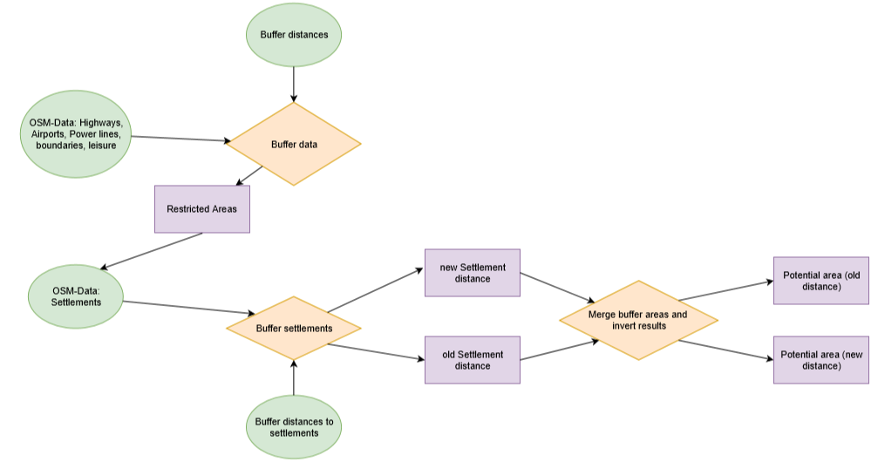

Figure 5: Workflow

Source: own figure

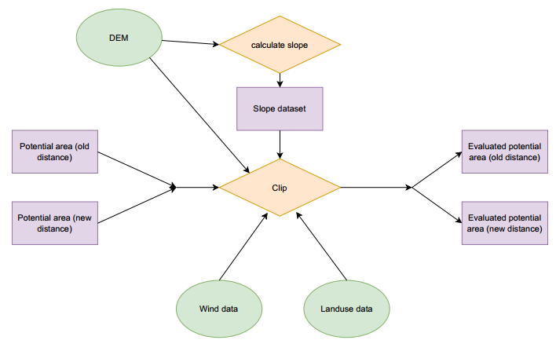

# Results

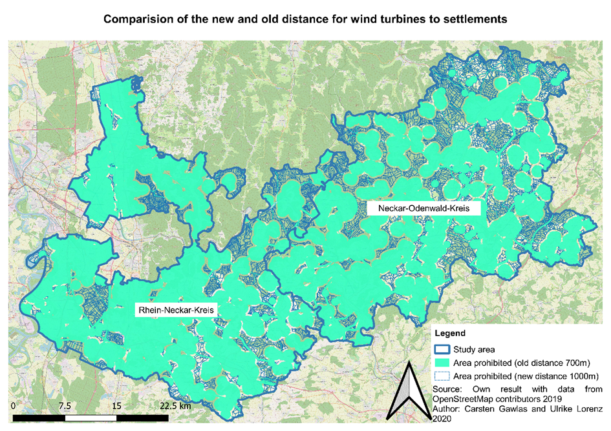

Figure 6: Result of the two distances

Source: own figure with data from OpenSteetMap contributors (2019)

Firstly, the area of both layers that are not available are counted to calculate the difference. This is done with the statistics tool. To get reliable results, the results are first warped to UTM. Results are shown in the Table 2.

Table 2: Comparison of the not available area regulated by minimum distances to infrastructure and settlements

Source: own figure

|  |  |  |  |
| --- | --- | --- | --- |
|  | Old Distance | New Distance | Difference |
| Overall Area [m²] | 2186176586.145 | 2186176586.145 | - |
| Unavailable Area [m²] | 1460894414.7458239 | 1710253943.806782 | 249359529.0609581  (249.36 km2) |
| Unavailable Area [%] | 66.82% | 78.23% | 11.4% |

This shows that the overall impact is significant. More than 10% of the overall area are no longer available for a wind turbine park when using the new distance to settlements.

With a second model the most suitable places within the remaining area are found. This means that first the area of each polygon (divided by streets) is calculated because a minimum area of 300 m² is needed to build a wind turbine park with three wind turbines. Then the slope is calculated. Slope should have a maximum value of 30 degrees. The next parameter is the windspeed in a height of 200 meters is considered too. A minimum mean wind speed of 6 meters per second is needed to have a productive wind turbine park. Furthermore, the land use is examined. The land use layer is reclassified as shown in Table 3.

Table 3: Classification of land uses for a wind turbine park

Source: own figure

|  |  |
| --- | --- |
| Land use | Available for a wind turbine park |
| Airports | No |
| Broad-leaved forest | Yes |
| Complex cultivation patterns | Yes |
| Coniferous forest | Yes |
| Continuous urban fabric | No |
| Discontinuous urban fabric | No |
| Dump sites | No |
| Fruit trees and berry plantations | Yes |
| Green urban areas | No |
| Industrial or commercial units | No |
| Inland marshes | No |
| Land principally occupied by agriculture with significant areas of natural vegetation | Yes |
| Mineral extraction sites | No |
| Mixed forest | Yes |
| Natural grasslands | Yes |
| Non-irrigated arable land | Yes |
| Pastures | Yes |
| Road and rail networks and associated land | No |
| Sport and leisure facilities | No |
| Transitional woodland-shrub | Yes |
| Vineyards | Yes |
| Water bodies | No |
| Water courses | No |

After looking up all those criteria for each remaining polygon the remaining areas are marked by a centroid to make it possible to show all areas within the study area. This analysis is made for the areas remaining after buffering with both the old and the new distance. To see the differences a layout with both results is chosen.

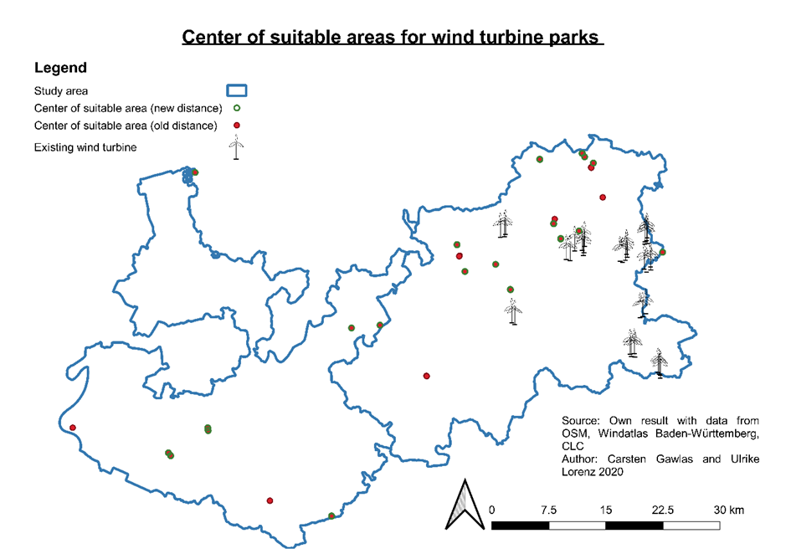

Figure 7: Centroids of the most suitable areas with the old and new buffer distance to settlements

Source: Own figure with data from OpenSteetMap contributors (2019), Albrecht et al. (2019) and Copernicus Land Service (2018)

According to the results shown in figure 7 it is obvious that the new minimum distance has an impact. It is shown that in some areas the results are the same, but obviously there are more red dots than green ones. This means that there are more areas that fulfil all criteria with the bigger areas of the old distance to settlements. Some of these results are close to other areas, so their weight is small. Although four red dots can be seen that are far from other dots, two in Rhein-Neckar-Kreis and two in Neckar-Odenwald-Kreis. These results are important because those areas can´t be considered any longer. Four suitable locations get lost by the new minimum distance to settlements.

To see if the results are meaningful, already existing wind turbines are added to the results. We can see that there are only wind turbines in Neckar-Odenwald-Kreis, but none in Rhein-Neckar-Kreis. This proves again that the expansion of wind energy is necessary and especially possible. All existing wind turbines are in the eastern part of Neckar-Odenwald-Kreis even though the analysis showed suitable places in the western part too. It is assumed that the existing wind turbines were not only built because of fulfilled criteria. The acceptance of the people is needed too. In the eastern part less population and less infrastructure are present which is the answer to the question why all wind turbine parks are built there up to now. Many of the existing wind turbines are close to the dots, which means that they are possibly within the area which is marked by a dot. These results seem good, however there are wind turbines in the south-eastern corner that seem far from the suitable areas located by this analysis. A reason for this could be that all layers were only reconsidered within the borders of the studied area which means that regions close to the outer border are less good in the representation of their potential.

# Discussion

The idea was to run everything in a batch process in GRASS GIS. This did not work, because of numerous problems with the software. These were difficulties with the different projections, which the data was in. Other Problems were probably caused by the build-up of GRASS GIS, which caused problems with the buffering and the union of polygons. These problems only occurred with GRASS GIS, not with QGIS. The problem was the data structure, because the attributes of the polygons got lost in the processing process. Another technical problem was the fact that GRASS GIS did not calculate a usable slope layer. The layer contained only some strikes and could therefore not be used.

Additional to the technical problems came also political problems. As shown the idea behind the bigger distance between turbines and settlements is to minimize the protest by residents. There are different, maybe more suitable ideas for getting a higher acceptance.

The model searching for the most suitable area starts with the area left over after buffering the infrastructure. The model makes a negative of this result to get the area that is not buffered. Then the polygons had to be split by another layer, otherwise it would give a wrong impression. Therefore, the streets were used for splitting because often streets dived big areas. But that does not mean that a street must be splitting an area in parts, because a wind turbine park can be built on two sides of a street and still be considered as one park. Then the area for each polygon is calculated, which does not include all adjacent polygons behind streets. It might be interesting to look at the area of the most suitable areas, the bigger the area the better. So a decision can be made where is the best place for a wind turbine park. For this analysis this could not be considered, because the area is already included in the analysis and it is not aimed to find the best one, but the ones that are most fitting with the criteria.

# Outlook

This work was executed with the goal, to make the process repeatable. That means that all the code is in our GitHub repository free to use by everyone.

Furthermore, it must be modelled how well an area is suitable for a wind turbine. Which means, that the wind data must be examined more closely. Because in this paper only the mean wind speed was taken in deliberation, however there are more wind parameters which must be considered in more detail.

For a more detailed research, there are more parameter to be investigated. That means population density, exposed location and other parameter which cause protest by local residents. Also, vegetation and animals that are protected were not considered yet but should be considered when a decision for a place is made.

# Declaration of Authorship

"We, the authors, hereby declare that this paper has been written by ourselves and without any unauthorized assistance. The parts of the work, which are taken from other works and sources, in terms of their wording or meaning, are marked as references in each individual case.”

10.04.2020 Carsten Gawlas and Ulrike Lorenz

This declaration has been digitally generated and is valid without a handwritten signature.

# Sources:

Albrecht, Carsten, Pauen, Raimund, Bloch, Christoph, Kemmerich, Tina (2019): Windatlas Baden-Württemberg 2019. Stuttgart: Ministerium für Umwelt, Klima und Energiewirtschaft.

Bergmann, M. & Höfle, B. (2013): GIS-gestützte Standortplanung von Windenergieanlagen mit freien und amtlichen Geodaten. In: Strobl, J., Blaschke, T., Griesebner, G. & Zagel, B. (Hrsg.) (2013): Angewandte Geoinformatik 2013. Berlin/Offenbach (Herbert Wichmann Verlag / VDE Verlag GMBH).

Bundesregierung (2020): Entwurf eines Gesetzes zur Reduzierung und zur Beendigung der Kohleverstromung und zur Änderung weiterer Gesetze (Kohleausstiegsgesetz). Berlin. http://dipbt.bundestag.de/dip21/brd/2020/0051-20.pdf (last accessed 28.03.2020).

Burger, Bruno (2020): Öffentliche Nettostromerzeugung in Deutschland im Yeshr 2019. Freiburg (Fraunhofer-Institut für Solare Energiesysteme ISE).

Copernicus Land Service (CLS) (2018): CORINE Land Cover (CLC). Version 20. Kopenhagen: European Environment Agency (EEA).

Der Spiegel (2020): Im Streit um Windräder wird weiter verhandelt. Online 12.03.2020. https://www.spiegel.de/wirtschaft/im-streit-um-windraeder-wird-weiter-verhandelt-a-678b2936-d7d7-4ec0-8f16-2b1be5255bd0 (last accessed 12.03.2020).

Dolinski, J., Schönewolf, J. L. & Dall, K. E. (2012): GIS-Modul: Digitale Kartengrundlage zur Eignung von Windenergiestandorten. In: Bachmann, E. M., Buning, M., Cislaghi, L., Dall, K. E., Diehl, I., Dietrich, F., Dolinski, J., Fischer, K., Geier, M., Gohn, C., Grün, W., Ilgner, F., Kiehl, S., Keller, M., Leba, M., Mathdorff, S., Richardt, L. K., Schnorr, M., Schuster, C., Schönewolf, J. L., Seif, J. V., Weigang, A., Prof. Dr. Diller, D., Dipl. Ing. Prof. Luterbacher, J., Ph.D. Dr. Erb, W.-D., Dipl. Geogr. Hoffmann, A. (2012): Projektbericht Regionalplanung und Klimawandel. Gießen: Institut für Geographie Gießen Klimatologie und Kommunale und Regionale Planung.

Fraunhofer-Institut für Solare Energiesysteme (ISE) (2020): https://www.energy-charts.de/power_inst_de.htm?year=all&period=annual&type=inc_dec (last accessed 05.03.2020)

Gesellschaft für Landmanagement und Umwelt mbh (2013): Standortanalyse für Windkraftanlagen zur Ausweisung von Konzentrationszonen für die Stadt Neustadt an der Aisch Westmittelfranken Bayern. Erläuterungsbericht. Weikersheim (Klärle).

Lechleitner, M., & Bohm, R. (2016). Kann durch Landesrecht ein Mindestabstand zwischen Windkraftanlagen und Wohngebäuden festgesetzt werden? (Wahlperiode Brandenburg, 6/21). Potsdam: Landtag Brandenburg, Parlamentarischer Beratungsdienst.

Opendata.info (2020): SRTM Digital Terrain Model of Germany. Internet: <https://www.opendem.info/download_srtm.html>.

OpenSteetMap contributors (2019): OpenStreetMap. Internet: <www.openstreetmap.org>.

Taeger, S., & Ulferts, L. (2017). Von Windparks umzingelt - oder nicht?‒ ein GIS-gestützter Ansatz zur Ermittlung der optisch bedrängenden Wirkung von Windenergieanlagen im Zuge der Regionalplanung. AGIT Journal, 3, 130-141.

Wieduwilt, P. D. (2018): Ein GIS-gestütztes Bewertungsverfahren zur Beurteilung des Beeinträchtigungspotenzials von Windenergieanlagen auf landschaftsprägende Denkmäler und historische Kulturlandschaften. Freiberg: Technische Universität Bergakademie Freiberg Fakultät für Wirtschaftswissenschaften.

WINDENERGIEERLASS BADEN-WÜRTTEMBERG (2012): Gemeinsame Verwaltungsvorschrift des Ministeriums für Umwelt, Klima und Energiewirtschaft, des Ministerium für Ländlichen Raum und Verbraucherschutz, des Ministeriums für Verkehr und Infrastruktur und das Ministerium für Finanzen und Wirtschaft. http://gewerbeaufsicht.baden-wuerttemberg.de/servlet/is/37557/Windenergieerlass_-_Ausser_Kraft_seit_09-Mai-2019.pdf (last accessed 26.11.2019).